Model Performance Test
Date | 08/10/2026
Team ID | SWTID-2026-3520
Project Name | Implement Client Script & UI Policy (Incident)
Maximum Marks | 10 Marks
Model Performance Testing:
Project team shall fill the following information in model performance testing template.
S.No. | Parameter | Screenshot / Values
1. | Data Rendered  (Incident form with Client Script & UI Policy) | - Incident form opens with all fields.  - Client Script hides/shows fields based on condition.  - UI Policy sets field mandatory/readonly/enabled as configured.  - Rendered form screenshot.  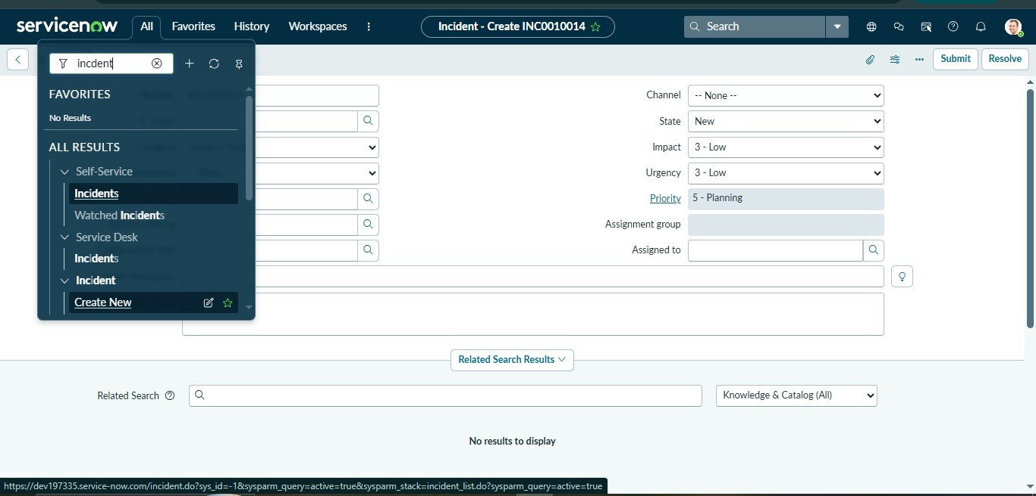
2. | Data Preprocessing  (Client Script Logic) | - Invalid data blocked (e.g., future date / special characters).  - Default values set by client script.  - Preprocessed data example / console log (if available).  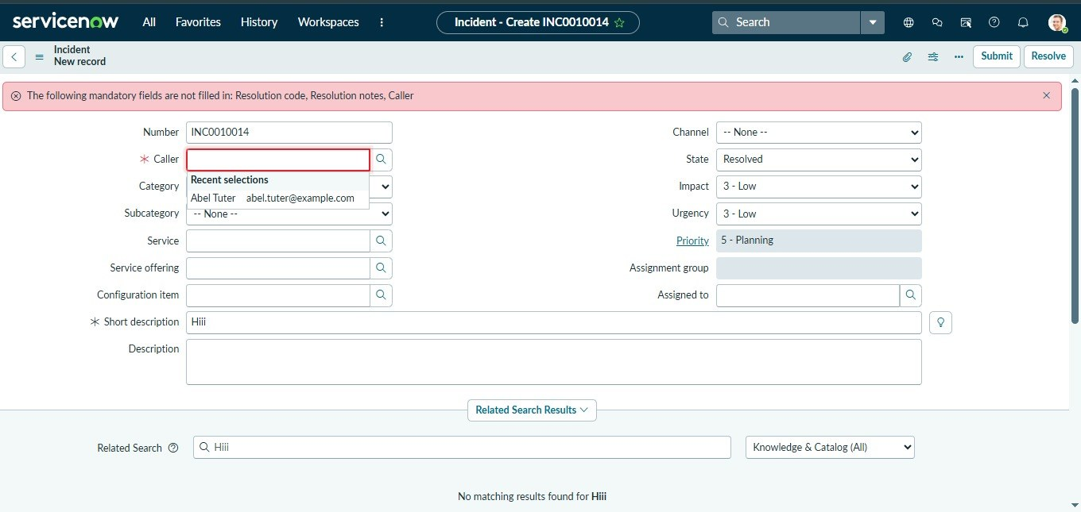
3. | Utilization of Data Filters  (UI Policy Conditions) | - Field visibility/mandatory status based on selected values.  - Different scenarios with screenshots (e.g., priority change, category selection).  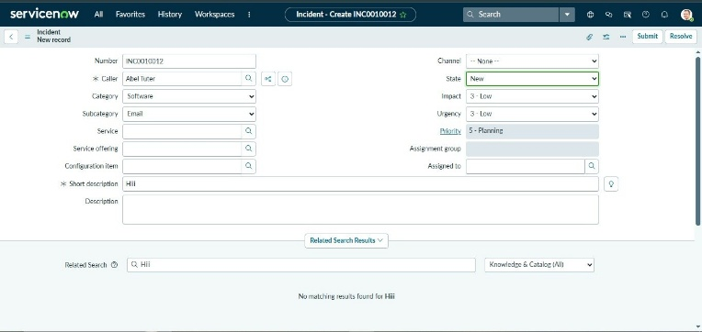
4. | DAX Queries Used  (If any – for reports/dashboards) | Not applicable for Incident (Client Script & UI Policy).  (Mention: No DAX queries used)
5. | Dashboard design  (If applicable) | Not applicable for Incident (Client Script & UI Policy).  (Mention: No dashboard required)

